 | ATTAQUANT ENTERPRISES PVT. LTD.

QUESTIONNAIRE FOR PRESSURE LEAF FILTER
Questionnaire for PLF
Name of Company
Address
Name of Concerned Person
PROJECT DETAILS
Filtration Area
Name of the product to be filtered | Liquid - solid -
Ph value of the liquid
Sp gravity of liquid
Bulk density of the liquid
Percentage of solids at the inlet
Micron size of the solids in the inlet
Max. Permissible Particle size at outlet (ppm_)
Expected cake volume (lit)
Nature of liquid | Acid
Nature of liquid | Neutral
Nature of liquid | Alkaline
Nature of particle | Sticky
Nature of particle | Non sticky
Nature of particle | Crystalline
Nature of particle | Crumbly
Nature of particle | Slimey
Nature of particle | Hygroscopic
Nature of particle | Pasty
Product to be recovered | Solid
Product to be recovered | Liquid
Is the purpose of your filtration to obtain | A clear filtrate
Is the purpose of your filtration to obtain | Recovery of the residue
Is the purpose of your filtration to obtain | Both
FILTRATION REQUIREMENTS:

Type of Filtration process | Continuous Batch process
If Continuous, flow rate (M.³/hr.)
If Batch | Batch size -
If Batch | No of batches per day -
Max. Operating temperature | ⁰C
pressure for filter vessel | Kg/cm²
Material of construction for filter vessel | SS 316 / SS 304/ MS
Material of construction for filter leafs | SS 316 / SS 304/ MS
Micron rating for filter mesh (micron)
Is Jacket required for filter vessel
If yes, material of construction for jacket
Cake Drying media
Any other specific requirement to be included in the process

Yours Faithfully,
For ATTAQUANT ENTERPRISES PVT LTD
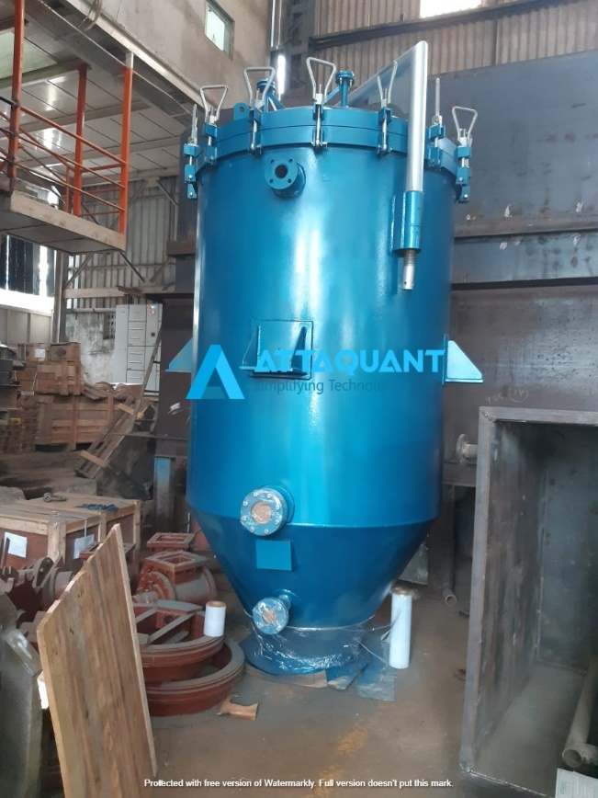
VIJAY PINATE
Mobile: +918788482769

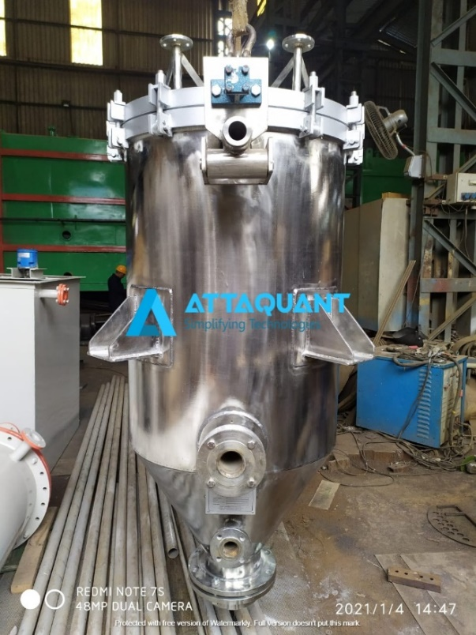


 Hyderabad Office:
Sales & Service – Office 1C,
Nandanavanam Complex, Sanjeeva Reddy Nagar, Near Metro Station, Hyderabad, 500038, India.

+91–8788482769
contact@attaquant.in
Manufacturing Unit:
Alandi Bypass Road, Gat No.138,
Near Growel Company,
At Post, Dhanore, Tal. Khed, Dist. Pune,
Maharashtra- 412105, India.

+91–9145205069
services@attaquant.in
Corporate Office:
601 (M 90), City Avenue,
Near Sayaji Hotel, Bhumkar, Chowk,
Wakad, Pune (Maharashtra), 411057,
India.

+91–8788482769/+91-9423589966
contact@attaquant.in, info@attaquant.in

